**COMMAND PROMPT**

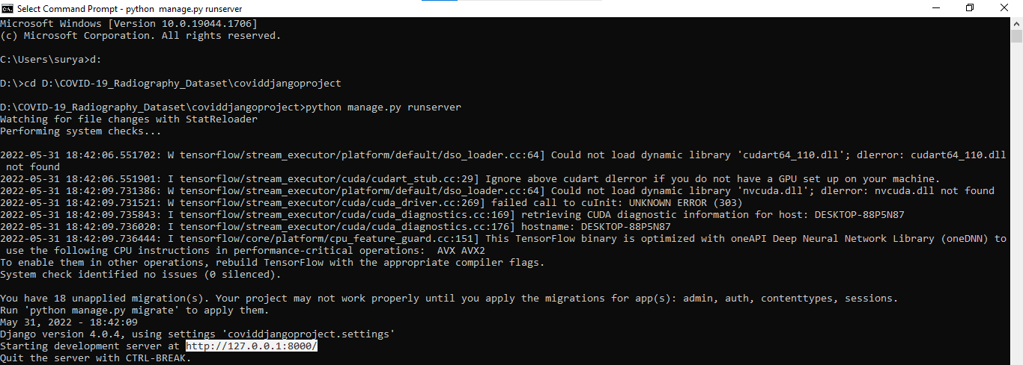

**Figure 1**

**OPENING IN BROWSER**

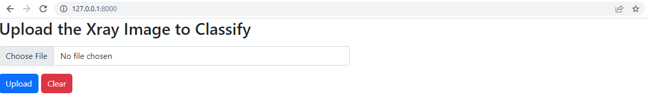

**Figure 2**

**SELECTING COVID IMAGE**

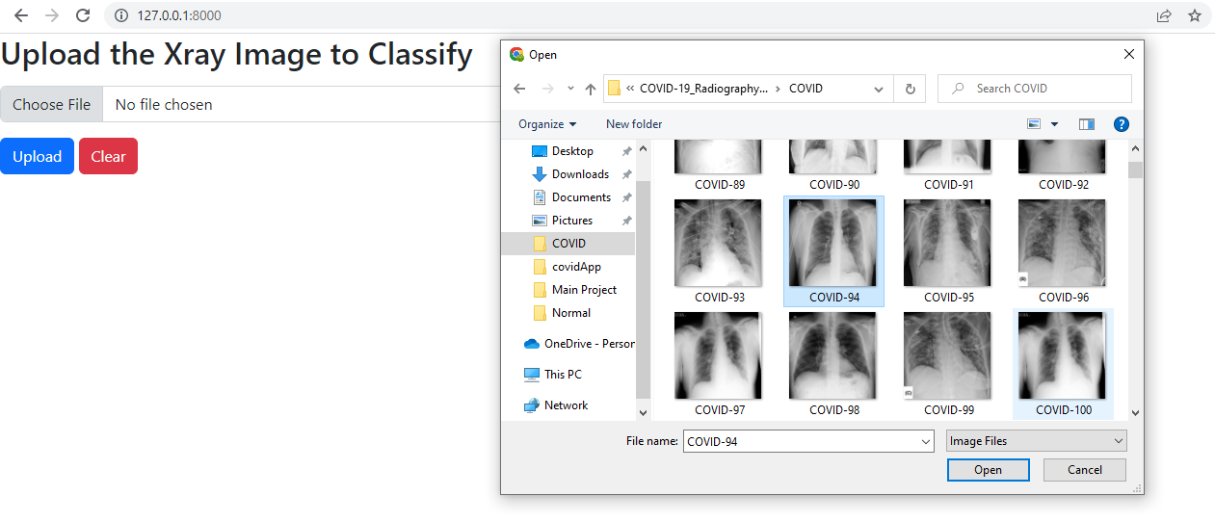

**Figure 3**

**UPLOADING THE IMAGE**

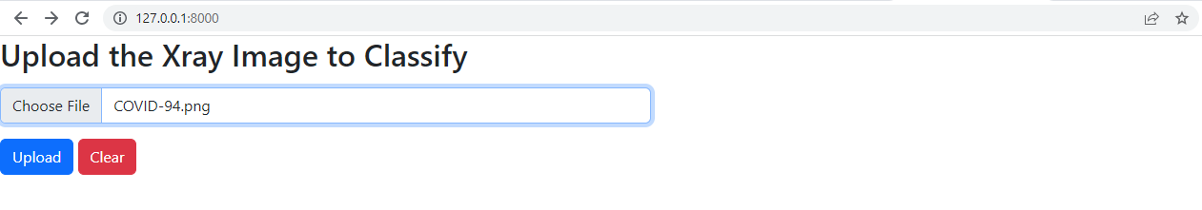

**Figure 4**

**RESULT**

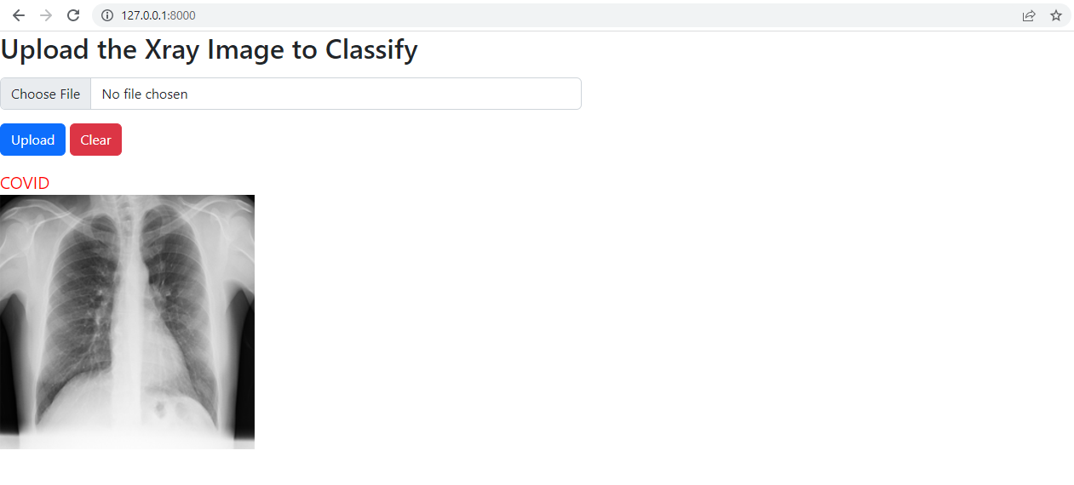

**Figure 5**

**SELECTING NORMAL IMAGE**

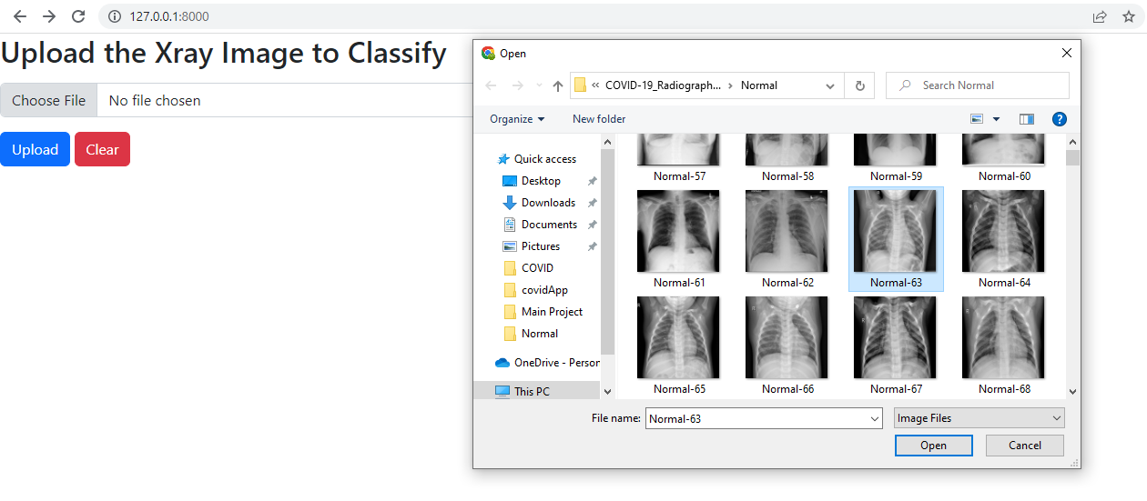

**Figure 6**

**UPLOADING THE IMAGE**

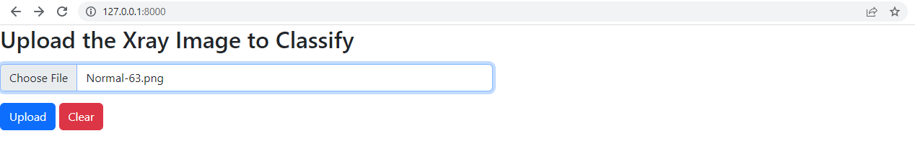

**Figure 7**

**RESULT**

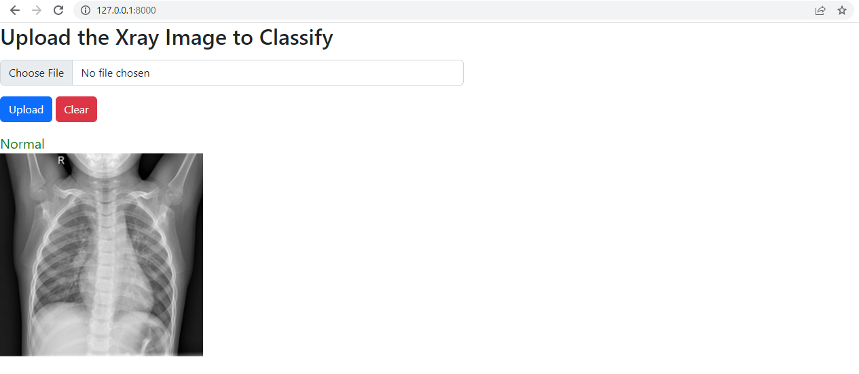

**Figure 8**